**PRESS RELEASE**

**COMMUNICATIONS AND MEDIA TEAM OF THE 2023 ASEAN SUMMIT**

**No.53/SP/TKM-ASEAN2023/ENG/5/2023**

**President Joko Widodo Visits Media Center of 42nd ASEAN Summit in Labuan Bajo**

**West Manggarai, 9 May 2023** **–** President Joko “Jokowi” Widodo made a visit to the Media Center of the 42nd ASEAN Summit 2023 at Bintang Flores Hotel, Labuan Bajo, West Manggarai, East Nusa Tenggara, Tuesday (9 May 2023).

The Head of State arrived at the location around 1:30 PM local Central Indonesian Time and immediately checked the press conference room. The President toured the media center in about five minutes to see the facilities and equipment.

President Jokowi visited the room used as a working space for journalists from various countries who cover the event. He also witnessed several media crews at work.

President Jokowi also made a visit to the dining area for journalists. He considered it necessary to know what dishes are served for the journalists covering the 42nd ASEAN Summit 2023.

During the visit, the Head of State was accompanied by Minister of State Secretariat Pratikno, the Minister of Public Works and Public Housing Basuki Hadimuljono, and the Director General of Public Information and Communications of the Ministry of Communications and Informatics Usman Kansong.

Previously, the Minister of Communications and Informatics Johnny G. Plate also inspected the readiness of each room in the Media Center.

Minister Johnny ensured that the digital and communications infrastructures properly work. The internet facility at the Media Center uses fiber optics with 4G and 5G signal quality.

*Telkomsel*, the cellular operator partner of the Media Center, has also added a large number of Base Transceiver Stations (BTS) and prepared Combat BTS.

The support of ICT infrastructures at the Media Center is expected to assist media crews in their participation to make the 42nd ASEAN Summit 2023 a success.

As of Wednesday (8 May), a total of 448 media have registered and been verified by the committee of the 42nd ASEAN Summit.

These media are 76 Indonesian-based foreign media, 45 foreign media, 152 national media, 122 DEOs, and 53 photo and broadcast hosts. (TR/Elvira/WW/PPR)

***

For more information, please contact:

**Director General of Public Information and Communications of the Ministry of Communications and Informatics – Usman Kansong (0816785320).**

Get more information at <http://asean2023.id>, <https://infopublik.id/kategori/asean-2023>, and <https://indonesia.go.id/kategori/ragam-asean-2023>

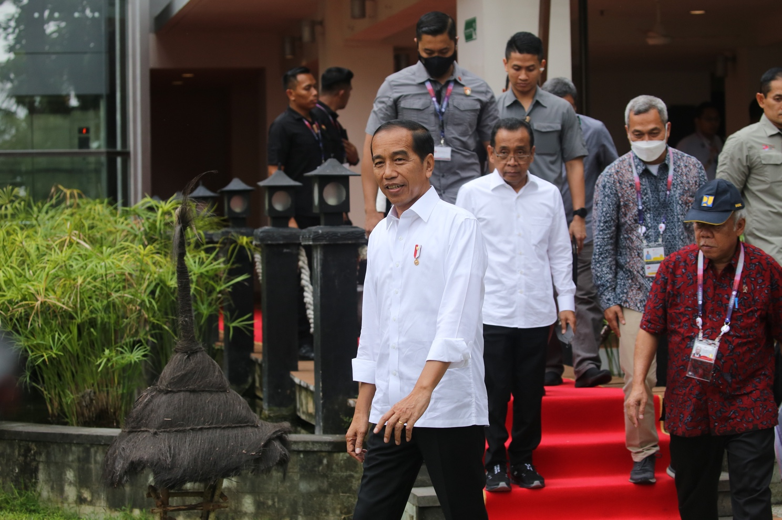

President Joko “Jokowi” Widodo visits the Media Center of the 42nd ASEAN Summit 2023 at the Bintang Flores Hotel, Labuan Bajo, West Manggarai, East Nusa Tenggara, Tuesday (9 May 2023). (Photo: Agus Siswanto/InfoPublik)

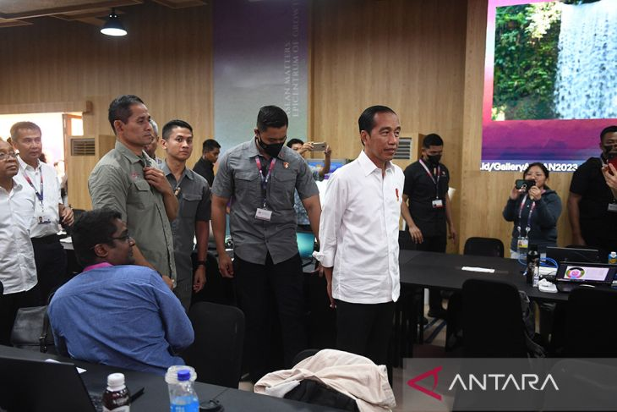

President Joko Widodo visits the Media Center of the 42nd ASEAN Summit 2023 at the Bintang Flores Hotel, Labuan Bajo, West Manggarai, East Nusa Tenggara, Tuesday (9 May 2023). ANTARA FOTO/Akbar Nugroho Gumay/nym.